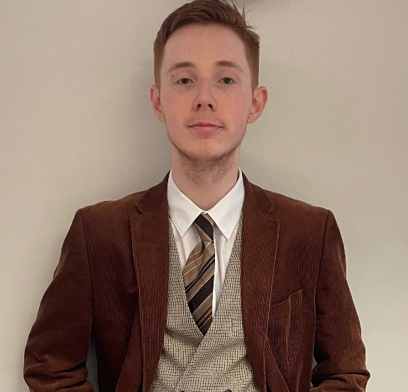
Freddie Mowat-Leyenda
Email: freddiemowatleyenda@icloud.com

Playing age: 16-24
Height: 5ft 10
Hair: Ginger
Eye: Blue
Gender: Male
Build: slim
Nationality: British

Training
- Currently studying Drama and Film at university (2024-2027)
- learning techniques in voice acting from “Gravy for the Brain” (since May 2025)
- I have done a full day’s voice training in London in January 2024
- Went to a Showreel “Character Voice” workshop with Yvonne Morley and JP in June 2025 and in person in December 2025.
- Went to a voice acting workshop in Canterbury that explains the behind-the-scenes (November 2025)
Credits Include
Production Roles Venue/Company Director
Production | Roles | Venue/Company | Director
Snow White (2026) | Narrator, Magic Mirror, Theo | Uni of Kent Drama Society | Charlotte and Georgia Wilson
Pawn (2026) | Simon | Uni of Kent Drama Society | Josie Blackburn
The Lion, The Witch, and the Wardrobe (2025) | Edmund | Uni of Kent Drama Society | Josie Blackburn
The Dark Knight scene creation (2025) | Joker | Uni Film Project | Kaylee Tang
Scream film project (2025) | Ghostface | Uni Film Project | Lenny Musumba
Accidental Death of an Anarchist (2025) | Bertozzo | Uni of Kent Drama Society | Harry Ainsworth
Peter Pan (2025) | Michael Darling | Uni of Kent Drama Society | Harry Ainsworth
The Unmoving (2025) | Mannequin and Boss | Uni Film Project | Ella Wood
Wizard of Oz (2024) | Scarecrow | Uni of Kent Drama Society | Chloe Jordan
Aladdin (2024) | Kazeer | Rare Productions | N/A
Oliver (2023) | Mr Bumble | Rare Productions | N/A
Egyptians (2023) | Choir and letter boy | Foreign office | Ramin Grey

Skills
Accents: Standard English
Voice Range: child, teenager, adult, monster, villain, deep, rich, presenter.

